**180DA Systems Design – Lab Report 1**

Utkarsh Kumar

UID: 505372436

For this week, I worked mostly on getting familiar with the different tools, such as Git, Miniconda, and OpenCV. I was having heavy difficulties with navigating Git since technical terms such as “commit”, “branches”, etc. were new concepts to me and it was my first time cloning a repository and working locally. Luckily I was able to complete task 1 and 2 which are both visible on my Github page:

<https://github.com/utkarshkumar7/180DA-WarmUp>

I was particularly fascinated by the OpenCV functions and code which I used to isolate the blue color displayed on my phone shown in the image below.

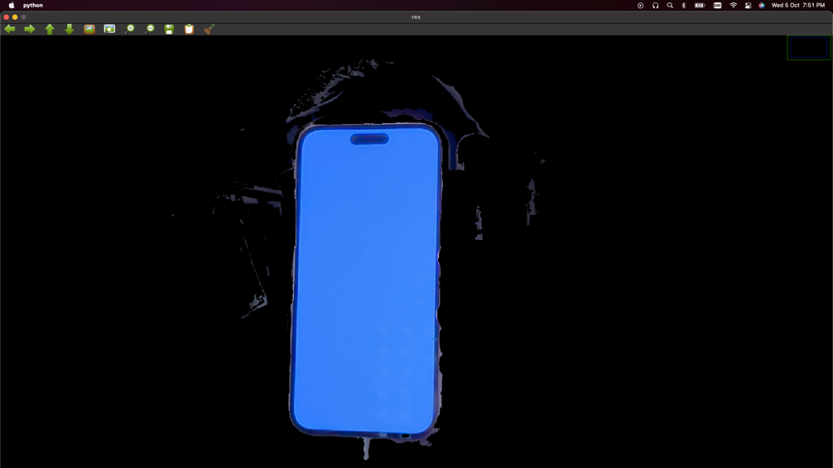

I also used K-means clustering to generate a bar chart of the most dominant colors (source: <https://code.likeagirl.io/finding-dominant-colour-on-an-image-b4e075f98097>)

